**Westlane** World Languages for Grades 6, 7 & 8

French & Spanish Year-Long Programs

Supply List for 2016-2017

**For ALL GRADES:**

**You need to:**

* Buy a three-subject notebook with college-ruled lines for your world language class – one with built-in pockets is most desirable

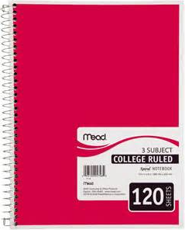

* 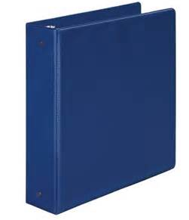Use your Grade Level 3-ring binder & dedicate ONE divider TAB label for your world language class

C:\Users\Luuisa\AppData\Local\Microsoft\Windows\Temporary Internet Files\Content.IE5\1M69G21P\MC900188523[1].wmf

* Always have a pen or pencil in your binder
* Keep a set of colored pencils in your binder
* Have access to a bilingual dictionary (Digital or Hard copy) at home

